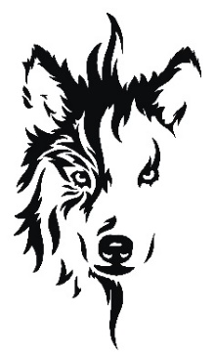

Puppy Application Form

Your assistance in completing this questionnaire helps us match the right puppy to the right home.
These questions are not intended to be intrusive; they allow us to determine whether a Lykos Wolfalike is suitable for your lifestyle and expectations, and they often raise topics that may not yet have been discussed.
All information supplied is treated as confidential.
After completing this form, please return it to us. If you have any questions or concerns, we are happy to help.
Thank you for your interest in a Beowolves puppy.

Applicant Details
Name: _________________________________________
Date: __________________
Address: _______________________________________________________

Suburb: _______________________________
State: __________________
Postcode: _______________
Mobile: _______________________________
Email: __________________________________________________________

Occupation(s): _________________________________________________
☐ Full time ☐ Part time ☐ Student ☐ Other: __________________

About Your Interest
What other breeds are you considering at this time?

How did you first learn about the Lykos Wolfalike?

Why does the Lykos Wolfalike appeal to you?

When are you hoping to welcome a new dog?

What type of temperament/personality are you looking for?

Experience & Lifestyle
Have you owned dogs or other pets before? Please describe.

Do you have adequate space for a dog to exercise daily?

Details: ___________________________________________________________

Is your yard securely fenced or do you have access to a safe exercise area?

Details: ___________________________________________________________

How many hours per day will the dog typically be left alone?

Who will be primarily responsible for feeding, training, and exercising the dog?

Responsibility & Commitment
Please confirm that you understand and accept the following:
- The time and consistency required for raising and training a dog
☐ Yes ☐ No
Details
- Routine grooming and coat maintenance
☐ Yes ☐ No
Details
- Legal requirements and council registration
☐ Yes ☐ No
- The financial costs of food, veterinary care, insurance, and unexpected expenses
☐ Yes ☐ No
- Recognising signs of illness and seeking veterinary attention promptly
☐ Yes ☐ No
- The specific needs of the Lykos Wolfalike breed
☐ Yes ☐ No
- A lifetime commitment to the dog
☐ Yes ☐ No

Additional Information
Is there anything else you would like us to know about your home, family, or expectations?

We appreciate the time you’ve taken to complete this application. It helps us make thoughtful, responsible placement decisions so each puppy thrives in the right environment.

